Photography & Filming Policy

Date created: 17 February 2020
Date last modified: 17 February 2020
Review date: 17 February 2023

- INTRODUCTION

This policy outlines how Geelong Gallery Limited (Geelong Gallery) will approach the taking of photographs, moving images and film when on Geelong Gallery premises.

- APPLICATION

This policy applies to all Geelong Gallery staff, members, contractors, volunteers and visitors.

- RESPONSIBILITIES

Director and Managers
The Director, department heads, managers and supervisors are responsible for:

ensuring that employees under their management are aware of, have an understanding of and are implementing the requirements of this policy; and

providing further training and instruction in the procedures noted in this policy, when requested by an employee or when requirements are identified in consultation with the employee.

Employees
Employees are responsible for:

maintaining an understanding of and implementing the requirements of this policy; and

requesting assistance as required in the implementation of this policy, escalating foreseeable issues to their manager.

3.3 Visitors

Visitors are responsible for:

3.3.1 ensuring they comply with the conditions and restrictions outlined in Clauses 4 through 6 of this policy, and conditions advertised in the Gallery and on the Gallery’s website.

3.3.2 requesting advice and clarification when necessary on whether photography is permitted.

- PHOTOGRAPHY

Visitors are permitted to take photographs with hand-held cameras and mobile devices within the Geelong Gallery for personal use, unless a particular exhibition or work has been expressly marked as restricted. Any images, moving images or film taken should not be reproduced or displayed on personal websites or social media platforms for gain without permission.

If an exhibition or work is restricted, the following signage will be displayed:

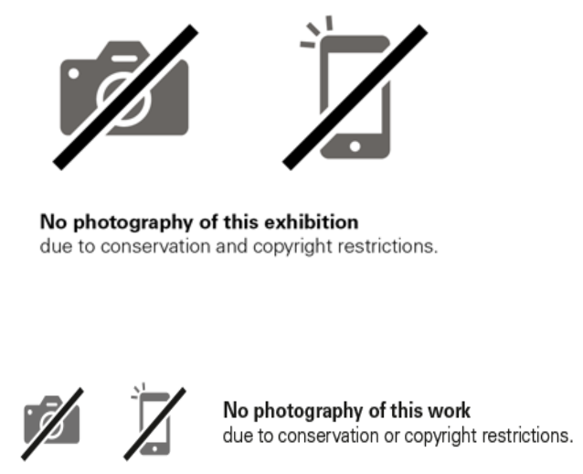

The use of tripods, selfie sticks, flash or additional lighting is not permitted without the permission of Geelong Gallery. A request must be made and granted before such equipment can be used in any gallery spaces.

- COPYRIGHT INFORMATION

Geelong Gallery respects artistic and intellectual property rights. Many of the works displayed at Geelong Gallery are subject to copyright legislation. The artist/copyright holder retains the right to reproduce a work of art.

No image, documentation or sound recording displayed at Geelong Gallery or appearing on the Geelong Gallery website may be reproduced, communicated or copied without permission, other than for the purposes of research or study. Use of and referral to this material is allowed for the purposes of research or study so long as full and proper attribution is given. For Indigenous works, this may include the artist and community.

Unauthorised commercial publication or reproduction of any part of the Geelong Gallery Collection is prohibited.

More information about copyright is available from the Australian Copyright Council at copyright.org.au.

- ASKING PERMISSION

Permission regarding the use of photographic equipment or access by the media or film crews may be granted by the Director subject to necessary consultation with relevant Collection Management, Exhibitions Management and Marketing staff, and be subject to relevant conditions and costs for the visitor.

It is the visitor’s responsibility to obtain permission from the copyright holders or their agent before a reproduction of any work or any other content is made. The Gallery will communicate to visitors that not adhering to these conditions may constitute an infringement of copyright which may incur penalties including fines.

